**Asp.Net MVC 動態DropdownList**

**前言:**

**在每個專案中，下拉選單幾乎是一定會存在於表單中的一個元件，面對幾乎不會變動的選項，我們可以直接寫死成Html。但是遇到會經常變動選項時，我們就必須隨著資料庫的變動，即時更新DropdownList的選項，而asp.net MVC也提供了幾種方法，能製作出即時更新的下拉選單。**

**Html.DropDownList:**

Controller:

**public** ActionResult Contact()

{

**var** CategoriesList = GetAllCategories();

ViewBag.CategoriesList = CategoriesList;

ViewBag.Message = "Your contact page.";

**return** View();

}

**public** List<SelectListItem> GetAllCategories()

{

List<SelectListItem> CategoriesList = **new** List<SelectListItem>();

**using** (NorthwindEntities db = **new** NorthwindEntities())

{

**foreach** (**var** item **in** db.Categories)

{

SelectListItem Category = **new** SelectListItem();

Category.Text = item.CategoryName;

Category.Value = item.CategoryID.ToString();

CategoriesList.Add(Category);

}

}

**return** CategoriesList;

}

將表單的Value及Text裝進List<SelectListItem>

View:

@Html.DropDownList("目錄", (List<SelectListItem>)ViewBag.CategoriesList)

執行結果:

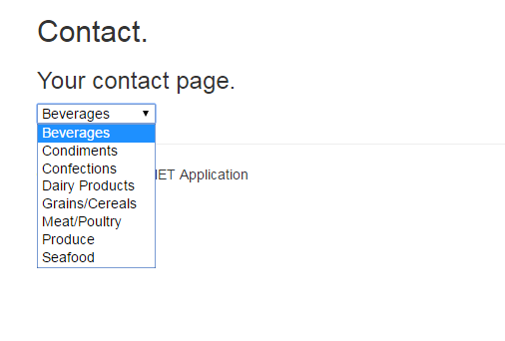

**下拉選單預設設定:**

Controller:

List<SelectListItem> CategoriesList = **new** List<SelectListItem>();

**using** (NorthwindEntities db = **new** NorthwindEntities())

{

**foreach** (**var** item **in** db.Categories)

{

SelectListItem Category = **new** SelectListItem();

Category.Text = item.CategoryName;

Category.Value = item.CategoryID.ToString();

Category.Selected = item.CategoryID.Equals(6);

CategoriesList.Add(Category);

}

}

執行結果:

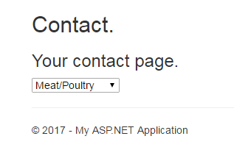

**使用SelectList取代SelectListItem:**

如果你的下拉選單的項目資料來源是集合物件，比較建議使用 SelectList 來取代 SelectListItemView

Controller:

**public** SelectList GetAllCategories()

{

List<Categories> CateGories;

**using** (NorthwindEntities db = **new** NorthwindEntities())

{

CateGories = db.Categories.ToList();

}

SelectList CategoriesList = **new** SelectList(CateGories, "CategoryID", "CategoryName");

**return** CategoriesList;

}

View:

@Html.DropDownList("目錄", (SelectList)ViewBag.CategoriesList)

**SelectList設定預設值:**

Controller:

SelectList CategoriesList = **new** SelectList(CateGories, "CategoryID", "CategoryName", 3);

加入第四個參數，即可指定下拉選單預設值。

**Html.DropDownListFor:**

將SelectList裝在ViewModel傳遞。

Model:

**public** **class** ContactViewModel

{

**public** SelectList SelectList { **get**; **set**; }

**public** **string** Message { **get**; **set**; }

}

Controller:

**public** ActionResult Contact()

{

**var** CategoriesList = GetAllCategories();

ContactViewModel VM = **new** ContactViewModel()

{

SelectList = CategoriesList,

Message = "Your contact page."

};

**return** View(VM);

}

**public** SelectList GetAllCategories()

{

List<Categories> CateGories;

**using** (NorthwindEntities db = **new** NorthwindEntities())

{

CateGories = db.Categories.ToList();

}

SelectList CategoriesList = **new** SelectList(CateGories, "CategoryID", "CategoryName", 5);

**return** CategoriesList;

}

View:

@Html.DropDownListFor(x => x.SelectList.SelectedValue , Model.SelectList)

第一個參數必須去指定 Model 的物件本身的屬性。

**參考資料:**

<http://kevintsengtw.blogspot.tw/2012/09/aspnet-mvc-3-dropdownlist.html>